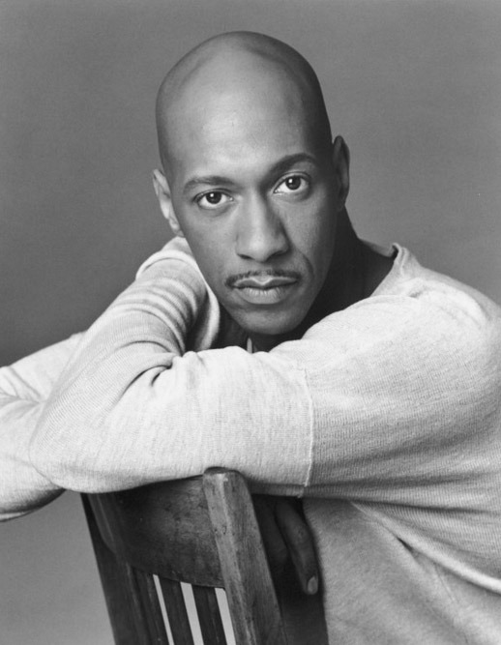

At
Rogers International School
Monday November 20, 2017

For Upper School Students:
Sign-up sheet for this workshop is located in the music hall way. This workshop is highly recommended if you’re planning to audition for the upper school spring musical in December. If you have any questions, please see Mr. Joe in the Danceroom or email: JJasmin@Stamfordct.gov Updates for future workshops and audition dates will be on located on RIS Drama Blog http://risdramablog.edublogs.org
David Robertson credits movement as the reservoir from which he draws his creative energy. He began his professional training at the Bernice Johnson Cultural Arts Center and strengthened his technique at the acclaimed high school of Performing Arts in Manhattan. Robertson made his Broadway debut in The Wiz. There he met choreographer George Faison. Under his tutelage, Robertson joined his creative team as assistant. Accompanying Faison in choreographing numerous industrial shows and music videos.
After enjoying a successful run on his home turf, Robertson received the call to head west (California) and began working alongside his mentor, the late Michael Peters. His work with Peter’s included choreography for numerous pioneering music videos of the ‘80’s. Including Michael Jackson’s “Thriller” and Lionel Richie’s “Dancing on the Ceiling,” among others.
Robertson created dance steps for Ashanti whose debut album was on the Murder, Inc./Island Def Jam label. He also worked on The Fighting Temptations, an MTV and Paramount Picture production starring Cuba Gooding, Jr., Beyoncé Knowles and Faith Evans. Another film credit is the Feature entitled Hair Show, which stars Mo’Nique the actress/comedic star of the hit TV series The Parkers. David has worked closely with Debbie Allen on several projects including the 61ST-63RD Annual Academy Awards.
Looking toward the future, David Robertson welcomes new evolutions to become a multi-faceted creative artist. Producing his first Documentary on Choreographer Louis Johnson, he nobly adds the title of filmmaker to his illustrious career.
“If I can continue to produce and bring forth works that change the way people think about life and the world around them, then my work is done.”

